|  |  |
| --- | --- |
| **FUNCTIONAL APPROVAL SHEET** | |
| Client Name | PT Astra International Tbk |
| Application Name | Mobile FS – Dashboard CMS |
| Function Name | Dashboard – CMS Mobile FS |
| Menu in Application | Master Data – Feedback Options |
| Version | 1.0 |

# Main Success Scenario: Master Data Feedback Options

1. **Introduction**
2. This is a new submenu in version v.1.0.
3. This page can be accessed by Admin (Area Leader).
4. This page is used to maintain Feedback Options. This part will be shown on Submit Feedback part in mobile FS application.
5. **Navigate to Form**
6. To load this form, User must access ‘(link CMS)’, log in to the application, then select ‘Master Data – Feedback Options’ as shown below:

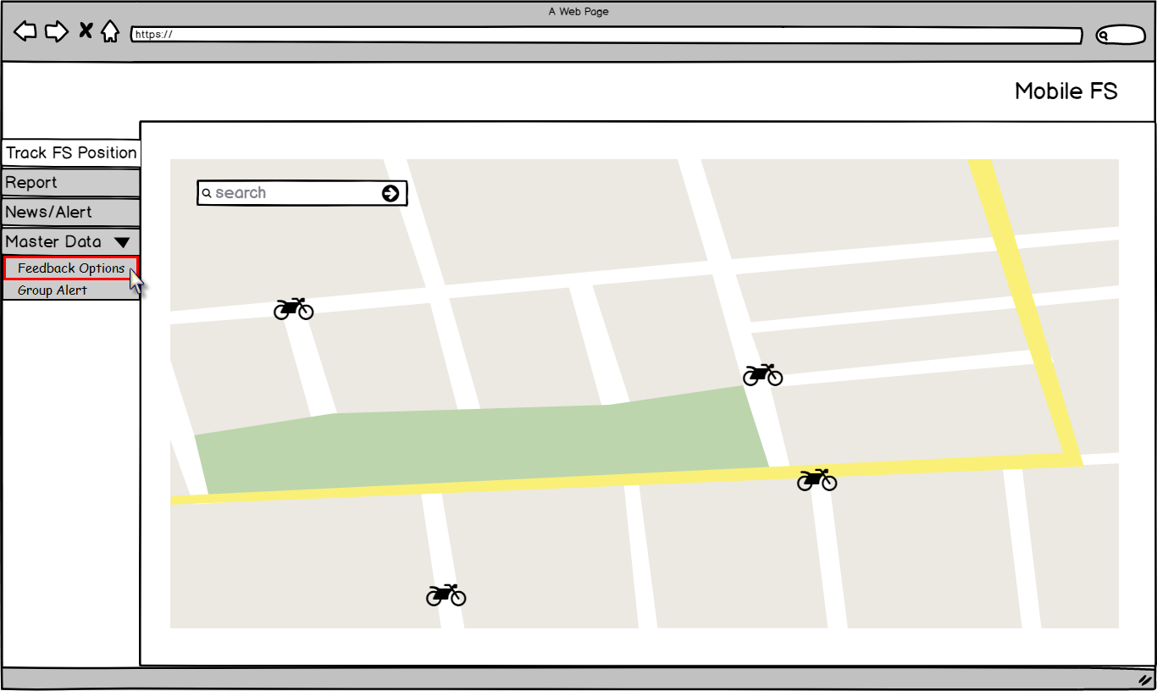

Figure 1 – Navigation to Master Data ‘Feedback Options’ – Mobile FS

1. Application will load following page:

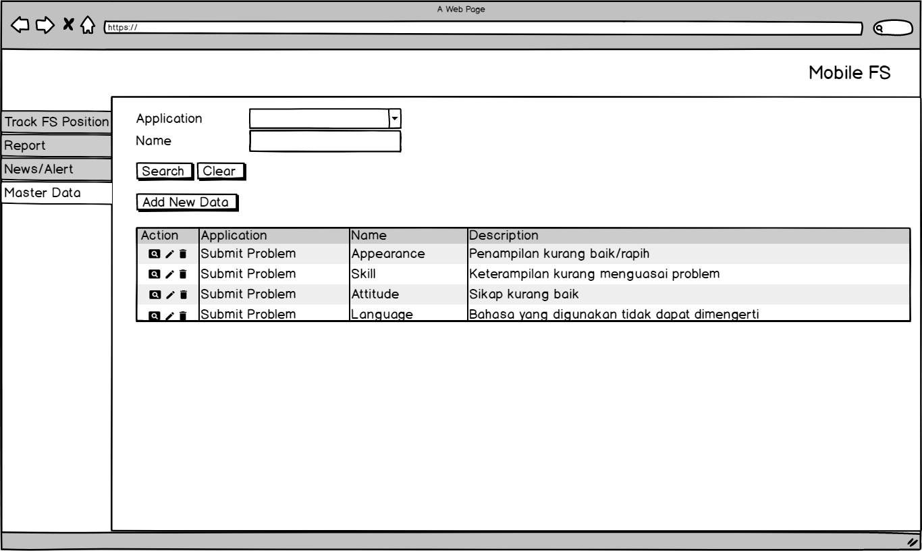

Figure 2 – Form ‘Feedback Options’ – Master Data

**Condition [Figure 2]:**

* Data displayed in Master Data Feedback Options data grid are data where IsDeleted = 0 and taken from following tables and columns:

|  |  |  |
| --- | --- | --- |
| **COLUMN IN DATA GRID** | **TABLE IN DATABASE** | **COLUMN IN DATABASE** |
| Application | AdditionalRating | ApplicationID |
| Name | Name |
| Description | Description |

* When initially loaded, application will enable following attributes:
* ‘Application’ combo box.
* ‘Name’ text field.
* ‘Search’ button.
* ‘Clear’ button.
* ‘Add New Data’ button.
* ‘Detail’ button.
* ‘Edit’ button
* ‘Delete’ button.
* Application will disable data grid.
* Admin can sort data grid by ascending or descending, by clicking the header of the data grid. If Admin did not sort the data, data will be displayed based on last updated data.
* Admin can search Feedback Options by selecting ‘Application’ and typing the feedback name on ‘Name’ text field, then click ‘Search’ button. Application will display list of Feedback Options that contain the inputted keyword. Here is the example if Admin selects ‘Submit Problem’ on Application dropdown menu and types ‘Appearance’ (highlighted in yellow):

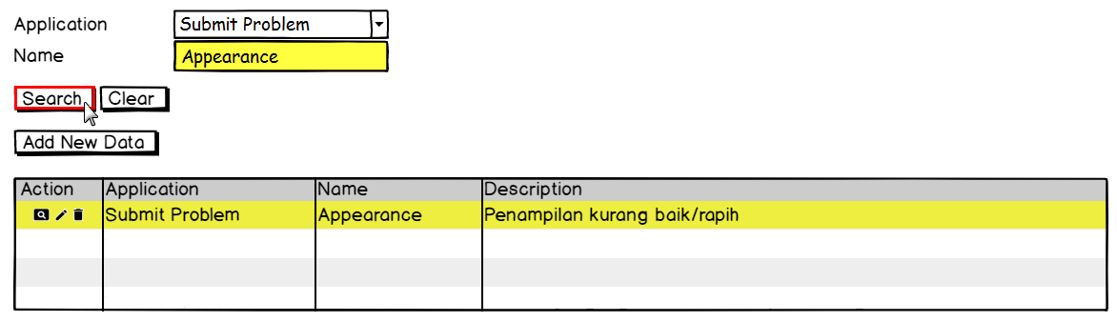

Figure 3 – Search Result – Master Data ‘Feedback Options’

Admin can clear the value on ‘Search’ text box by clicking ‘Clear’ button, and then application will re-display the entire data.

1. **Function Provided in Form**

In this form, User can view, add, edit, and delete data as follow:

1. View data.

To view detail of existing data, Admin must do following steps:

* 1. Log in to the application, then select ‘Master Data – Feedback Options’ as shown below:



Figure 4 – Navigation to Master Data ‘Feedback Options’

* 1. Then application will display list feedback options in a following page as shown below:



Figure – Form ‘Feedback Options’ – Master Data

* 1. Admin clicks ‘Detail’ button, then application will display detail of selected data as shown below:

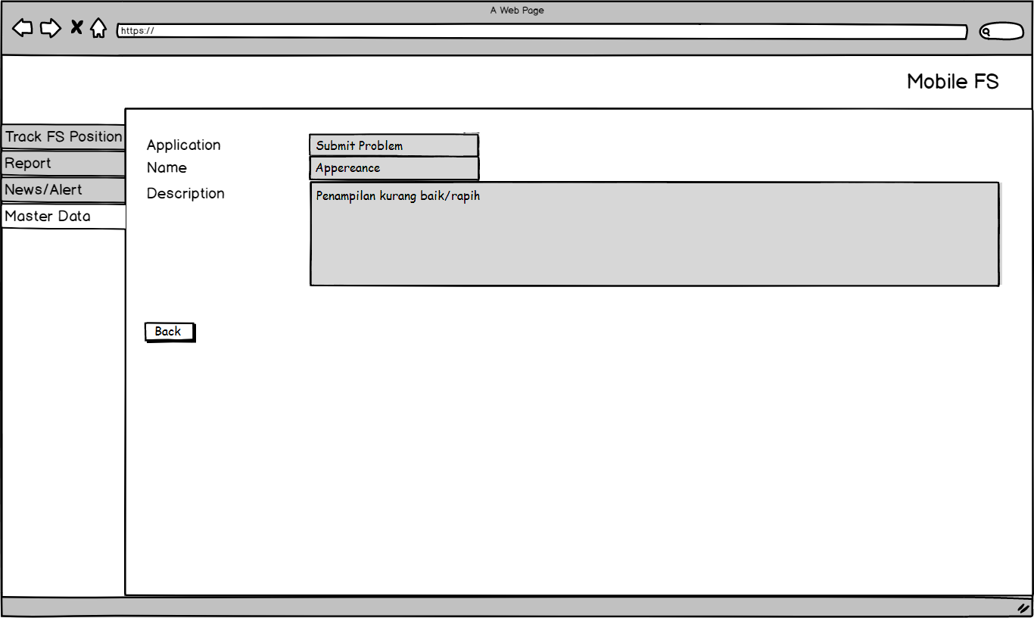

Figure 6 – View Detail - Master Data Feedback Options

**Condition [Figure 6]:**

* When initially loaded, application will enable following attributes:
  + ‘Back’ button.
* Application will disable following attributes:
  + ‘Application’ text field.
  + ‘Name’ text field.
  + ‘Description’ text box.

1. Add data.

To add new data, Admin must do following steps:

1. Admin clicks ‘Add New Data’ and application will display following page:

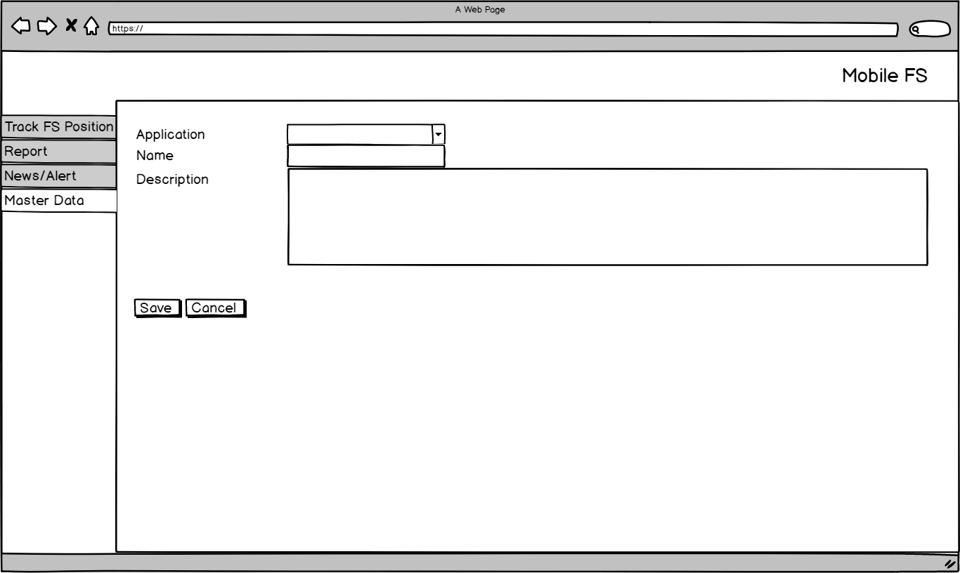

Figure 7 – Add New Data Form – Master Data Feedback Options

**Condition [Figure 7]:**

* When initially loaded, application will enable following attributes:
* ‘Application’ combo box.
* ‘Name’ text field.
* ‘Description’ text area.
* ‘Save’ button.
* ‘Cancel’ button.

1. Admin selects ‘Application’ combo box, to set the feedback options in certain service.

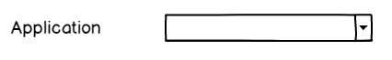

Figure 8 – ‘Application’ Dropdown Menu – Master Data Feedback Options

**Condition [Figure 8]:**

* This is a mandatory field.
* In this field, admin can decide the feedback options will be shown in which application menu.
* For current condition, the only available option is ‘Submit Problem’.

1. Admin inputs the name of the options in ‘Name’ text field.



Figure 9 – ‘Name’ Text Field – Master Data Feedback Options

**Condition [Figure 9]:**

* This is a mandatory field.
* This field can be filled with alphanumeric.

1. Admin inputs the description of the options in ‘Description’ text area.



Figure 10 – ‘Description’ Text Area – Master Data Feedback Options

**Condition [Figure 10]:**

* This is a mandatory field.
* This field can be filled with alphanumeric.

1. Admin clicks ‘Save’ button, then application will apply following conditions:
   * 1. Check whether mandatory field has been filled.
     2. If the validation has passed successfully, then the inputted data will be inserted into table (AdditionalRating) in following columns:

|  |  |
| --- | --- |
| **COLUMN IN DATABASE** | **DESCRIPTION** |
| ID | Auto generated by system. |
| RowStatus |  |
| ApplicationID | Selected name of the service (sub menu) |
| Name | Inputted name of the feedback options that will be shown in mobile FS application.  Example: ‘Bad Attitude’. |
| Description | Inputted description of the feedback options.  Example: ‘Bicara kurang sopan’. |
| CreatedBy | Username who creates this data |
| CreatedOn | Date when data has been created |
| ModifiedBy | Empty / blank |
| ModifiedDate | Empty / blank |
| TimeStatus |  |

1. The Master ‘Feedback Options’ data grid will have following conditions:

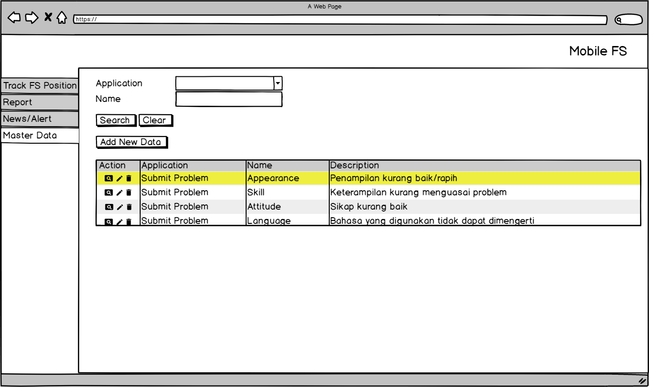

Figure 11 – Master ‘Feedback Options’ Form – Master Data

1. If Admin clicks ‘Cancel’ button, then application will go back to the previous page.
2. Edit data.
3. Admin clicks ‘Edit’ button in data grid, and application will display following page:

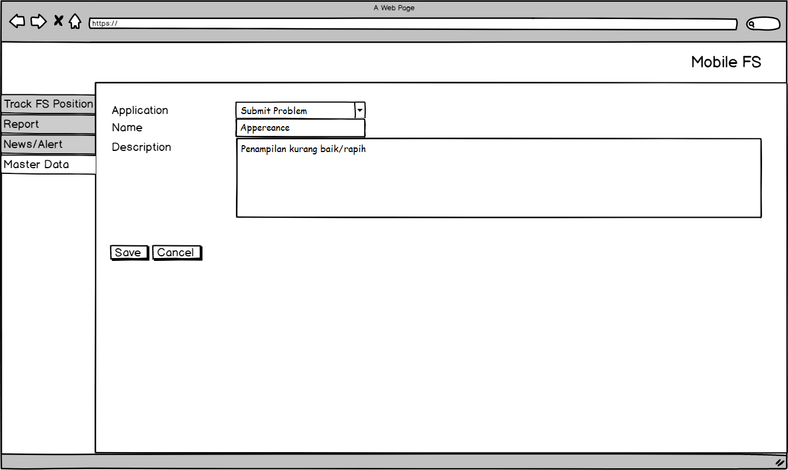

Figure 12 – Edit Form – Master Data Feedback Options

1. Admin selects ‘Application’ combo box, to edit the feedback options in certain service.



Figure 13 – ‘Application’ Dropdown Menu – Master Data Feedback Options

**Condition [Figure 13]:**

* This is a mandatory field.
* In this field, admin can decide the feedback options will be shown in which service.
* For current condition, the only available option is ‘Submit Problem’.

1. Admin edits the name of the options in ‘Name’ text field.



Figure 14 – ‘Name’ Text Field – Master Data Feedback Options

**Condition [Figure 14]:**

* This is a mandatory field.
* This field can be filled with alphanumeric.

1. Admin edits the description of the options in ‘Description’ text area.



Figure 15 – ‘Description’ Text Area – Master Data feedback Options

**Condition [Figure 15]:**

* This is a mandatory field.
* This field can be filled with alphanumeric.

1. Admin clicks ‘Save’ button, then application will apply following conditions:
   * 1. Check whether mandatory field has been filled:
     2. If the validation has passed successfully, then the edited data will be updated into table (AdditionalRating) in following columns:

|  |  |
| --- | --- |
| **COLUMN IN DATABASE** | **DESCRIPTION** |
| ID | Auto generated by system. |
| RowStatus |  |
| ApplicationID | Selected name of the service (sub menu). |
| Name | Edited name of the feedback options that will be shown in mobile FS application.  Example: ‘Bad Attitude’. |
| Description | Edited description of the feedback options.  Example: ‘Bicara kurang sopan’. |
| CreatedBy | Username who creates this data. |
| CreatedOn | Date when data has been created. |
| ModifiedBy | Username who edited this data. |
| ModifiedDate | Date when data has been edited. |
| TimeStatus |  |

1. The Master ‘Feedback Options’ data grid will have following conditions:



Figure 16 – Master ‘Feedback Options’ Form – Master Data

1. If Admin clicks ‘Cancel’ button, then application will go back to the previous page.
2. Delete data.
   1. Admin clicks ‘Delete’ button in data grid, and application will display a pop up confirmation message as shown below:

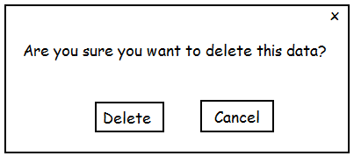

Figure 17 – ‘Delete’ Confirmation Message – Master Data Feedback Options

* + 1. If Admin clicks ‘Delete’ button, then application will apply following conditions:
       1. Update the selected data IsDeleted = 0 into IsDeleted = 1.
       2. Remove the selected data from Master Feedback Options data grid.
    2. If Admin clicks ‘Cancel’ button, then application will go back to previous page.

# Extension

When ‘Search’ button clicked in search Feedback Options function:

1. If ‘Application’ dropdown menu is not selected, following message will be shown:

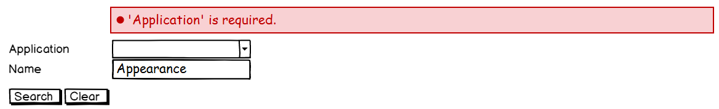

Figure 18 – Error Message – Master Data ‘Feedback Options’

1. If ‘Name’ text field is empty, following message will be shown:

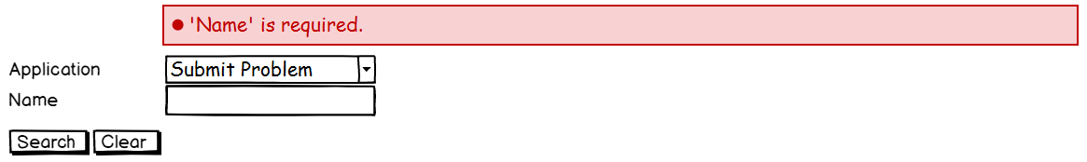

Figure 19 – Error Message – Master Data ‘Feedback Options’

When ‘Save’ button is clicked in Add and Edit functions:

1. If ‘Application’ combo box is not selected, following message will be shown:



Figure 20 – Error Message – Master Data ‘Feedback Options’

1. If ‘Name’ text field is empty, following message will be shown:



Figure 21 – Error Message – Master Data ‘Feedback Options’

|  |  |  |  |
| --- | --- | --- | --- |
| PREPARED BY | REVIEWED BY | | APPROVED BY |
|  |  |  |  |
| Name: Rizky Fitriandini | Name: Yongkie Saputra | Name: Rahmat Hidayat | Name: Arif |
| Moonlay Business Analyst | Moonlay Project Manager | Product Manager | Project Owner |
| Date: March 20th, 2018 | Date: April 10th, 2018 | Date: | Date: |

Copyright © Moonlay Technologies. All Rights Reserved.